TASK 1:

#include<iostream>

using namespace std;

int main()

{

int x=1;

do {

cout<<"enter a number";

cin>>x;

}

while(x>0);

return 0;}

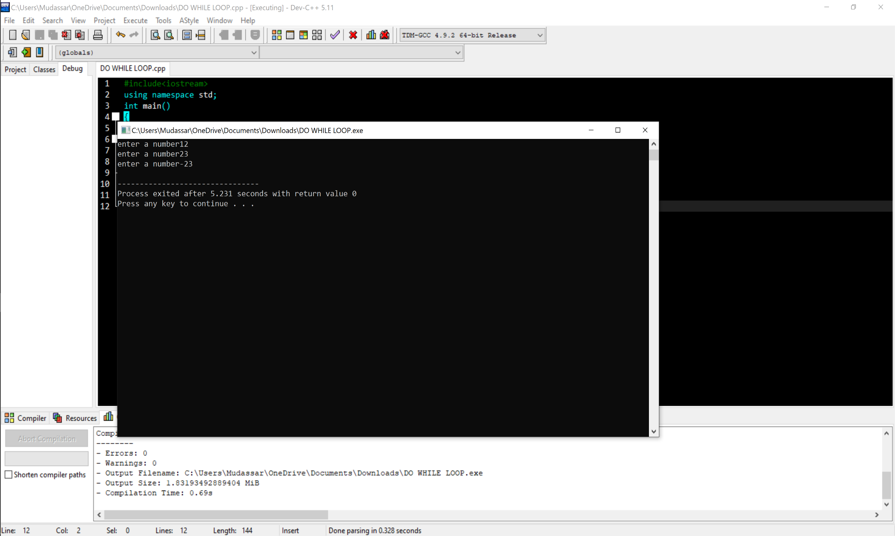

TASK 2:

#include<iostream>

#include<math.h>

using namespace std;

int main(){

char choice;

double x, y;

double result;

do {

cout << "Enter first number: ";

cin >> x;

cout << "Enter an operator (+, -, \*, /, %, ^): ";

cin >> choice;

cout << "Enter second number: ";

cin >> y;

switch (choice) {

case '\*' : {

result = x \* y;

break;

}

case '/' : {

result = x / y;

break;

}

case '+' : {

result = x + y;

break;

}

case '-' : {

result = x - y;

break;

}

case '%' : {

result = fmod( x,y );

break;

}

case '^' : {

result = pow( x,y );

break;

}

default : {

cout<<"Your opperator is invalid"<<endl;

break;

} }

cout << "Result: " << x << " " << choice << " " << y << " = " << result << endl;

cout << "Do you want to perform another calculation? (y/n): ";

cin >> choice;

} while (choice == 'y' || choice == 'Y');

}

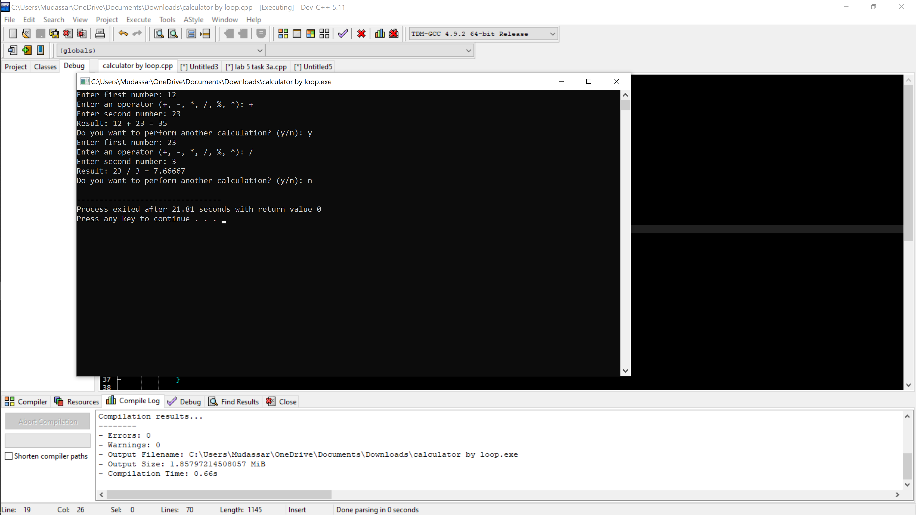

TASK3

Part a

#include<iostream>

#include<math.h>

using namespace std;

int main()

{

int res = 0, x = 0;

do {

if ( x % 2 == 0 && x != 0 && x != 1) {

res = res + x;

}

x++;

} while ( x < 101 );

cout<<"The sum of all even numbers between 0 to 100 is:"<<res;

}

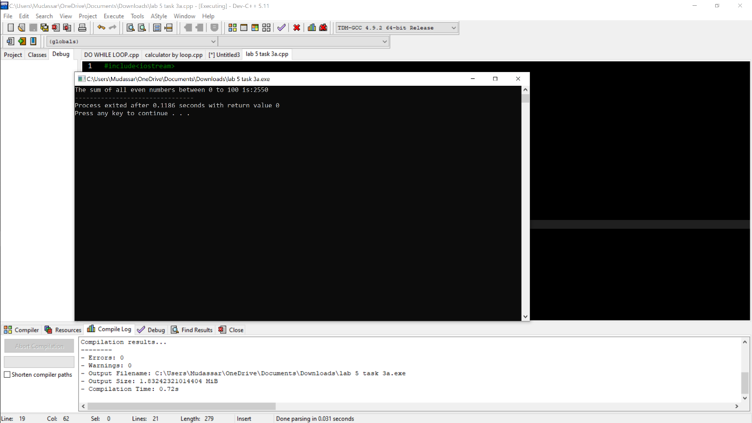

Part b

#include<iostream>

#include<math.h>

using namespace std;

int main()

{

int

sum = 0;

int x = 0;

double y;

do {

y = pow (x,2);

sum = sum + y;

x++;

} while (x<101);

cout<<"The sum of all squares between 1 and 100 is: "<<sum;

return 0;

}

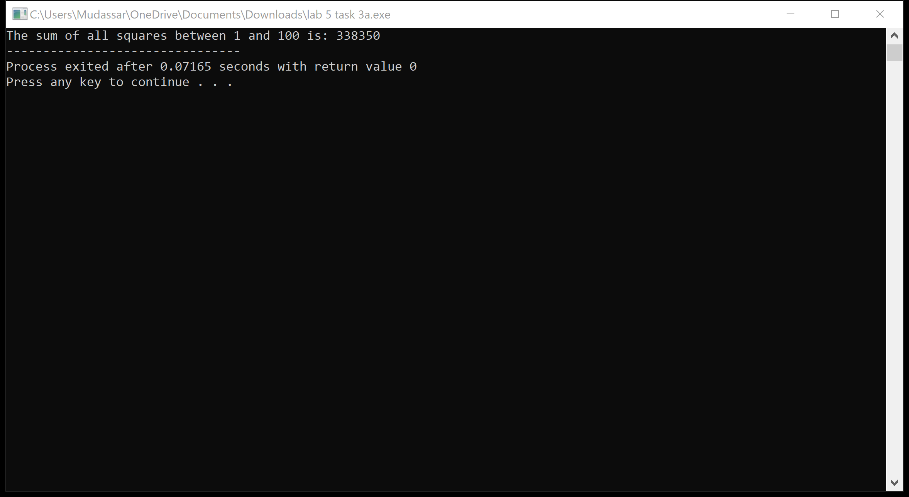

TASK 4:

PART A:

#include<iostream>

#include<math.h>

using namespace std;

int main()

{double x = 0;

do {

cout<< pow( 2,x )<<" ";

x++;

} while ( x <= 20 );

}

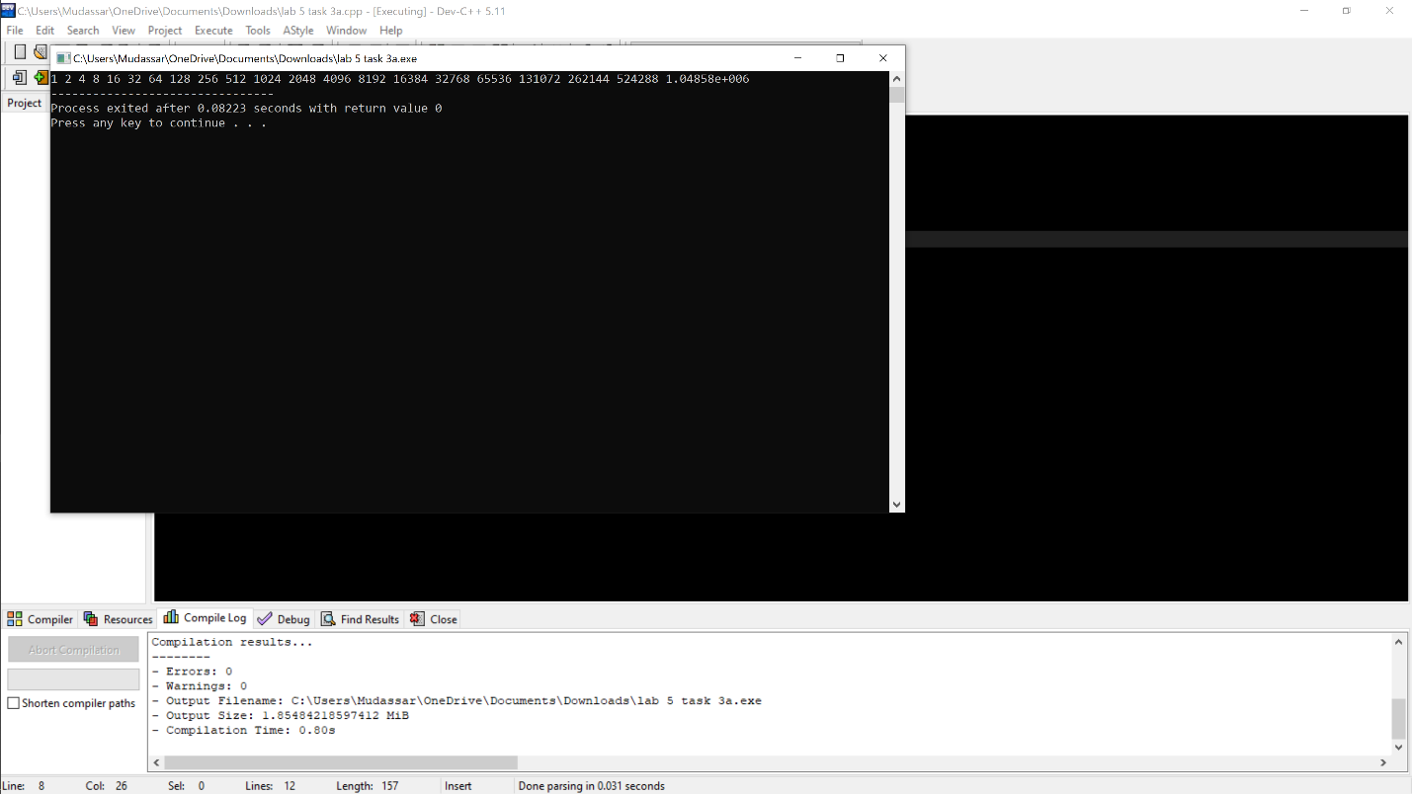

PART B:

#include<iostream>

#include<math.h>

using namespace std;

int main()

{int a, b, sum;

cout<<"ENTER TWO NUMBERS"<<endl;

cin>>a>>b;

do {

if ( a % 2 == 1 ) {

sum = sum + a;

}

a++;

} while ( a <= b);

cout<<"SUM OF ALL ODD NUMBERS BETWEEN TWO INTEGERS IS: "<<sum;

return 0;

}

